WORKBOOK

Day 2: Practice

Overview of practice exercises

Strategy | Selecting / organizing | Elaboration | Practicing
1. ANKI-Flashcards | X | X | X
2. Self-explanations |  | X | X
3. Read-recite-review | X |  | X
4. Cornell-note taking | X | X | X
5. Brain-Dump |  |  | X
6. Mapping / Visualization | X | X

This is an overview of all practice exercises. These exercises include examples of how to apply the principles of effective learning (being active and critical, testing yourself regularly on your knowledge, integrating knowledge with what you already know and getting accurate feedback).
The overview shows on which aspect of the learning cycle, the different strategies focus on: selecting and organizing information, elaborating on the information or practicing and integrating it with prior knowledge.

Choose one of these exercises and apply the strategies on your own learning materials.

Practice: Effective learning strategies

1. Anki-Flashcards

The essence of practice tests is: questioning yourself. This is a form of "retrieval practice": retrieving information from your memory. In this sense, it is actually a training of remembering. By answering practice questions, you are checking whether you can actively retrieve the studied materials from memory when asked. You hereby commit yourself to thinking more deeply. Possible ways of practicing retrieving information from your memory are:
- Complete practice tests (which you can write yourself, or get from teachers)
- Ask yourself questions about what you have studied, explain the answers to yourself and check whether the answers you gave yourself were indeed correct
- Someone else asks you a question and you explain the subject matter
- Create a practice test on flashcards about the text you need to learn (on paper or online: https://apps.ankiweb.net/ )

1. Take your learning material and make 5 flashcards out of it

For this exercise, you will practice making flashcards. There are different type of cards, the most common one are:
  - Basic card: one question & answer, e.g. What is the capital of Limburg? Maastricht
  - Cloze deletion: e.g., The capital of Limburg is ___ .

Example

Front (question/keyword) | Back (answer/explanation)
What are effective learning strategies for long-term learning? | Make practice tests ("retrieval practice")  &  Distributed practice (returning to the topics you need to learn more often)
Which principles make learning strategies effective? | Active learning (actually actively working with the subject matter, for example asking questions about it) and immediate feedback (knowing whether you are doing well and why)
What are "desirable difficulties"? | Learning conditions that make initial learning more difficult but enhance long-term learning. This is the case in testing yourself (compared to rereading) or distributing study sessions over time (compared to crammed learning). Note: not everything that makes learning difficult (for example distractions) is desirable!

While you can make flashcards on paper, online flashcards are a very good and helpful alternative as you can keep an easy overview, observe your progress and the app help you with a smart algorithm to distribute your learning over time and to fight the forgetting curve.

2. Self-enroll in the CANVAS course ANKI: https://maastrichtuniversity.instructure.com/enroll/P673MA
We highly recommend the app Anki: https://apps.ankiweb.net/
In the canvas course you will find an introduction, several tutorial video’s and a manual on how to install Anki, how to make cards and how to study with that app.
3. Take the tutorial (watch videos), install ANKI and get familiar with the app

2. Self-explanations

Asking questions before and while reading a text for the first time

We want to understand why things are the way they are. If we understand, we can remember it better. The materials are not only anchored more strongly in our memory, but also linked to our prior knowledge. That is why, while reading a text, you ask yourself questions about your learning materials and answer these questions for yourself or by explaining it to others.
- Get an overview about your learning material and the structure of it
- Read or watch the first section(s) of your learning material
- Ask yourself about what you have just read:
  - Why? and How?
  - How does this work?
  - Why is this important in my field of study?
  - How does this relate to what I’ve learned before?
- Explain what you just have read and answered to yourself or someone else (without looking at the text) & check afterwards whether you were able to explain it correctly

Example
Paragraphs in the text | Questions you might ask
Why don’t students use more effective study techniques?  It seems they are not being taught the best strategies, perhaps because teachers themselves are not schooled in them.  A second problem may be that in the educational system, the emphasis is on teaching students critical-thinking skills and content. Less time is spent on teaching them how to learn.  The result can be that students who do well in their early years, when learning is closely supervised, may struggle once they are expected to regulate their own learning in high school or college. | Which strategies?  Why don’t students learn how to learn?  What is the result of this?
Some questions, such as the best age for students to start using a technique and how often they will need to be retrained or reminded, still require further research.  But even now teachers can incorporate the most successful approaches into lesson plans so that students could adopt them on their own.  For instance, when moving to a new section, a teacher can start by asking students to do a practice test that covers important ideas from the previous section and providing immediate feedback.  Students can interleave new problems with related ones from preceding units. Teachers can harness distributed practice by reintroducing major concepts during the course of several classes.  They can engage students in explanatory questioning by prompting them to consider how the information is new to them or why it might be true. | What could teachers do?  How can teachers support their students?  What does interleaving mean?
Adapted from: Dunlosky, J., Rawson, K. A., Marsh, E. J., Nathan, M. J., & Willingham, D. T. (2013). What works, what doesn’t. Scientific American Mind, 24(4), 46-53.

Actively summarizing texts

3. The Read-recite-review method
Summarization can be a very effective as well as an extremely ineffective learning strategy. It is crucial that you are active while writing your summary, that means: write it in your own words (no copy-pasting from the textbook or lectures), think about examples or your own explanations, and include opportunities to test your knowledge in your summary. One way to do so, is the read-recite-review method:
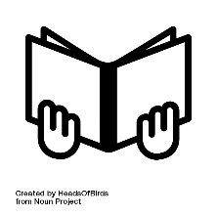
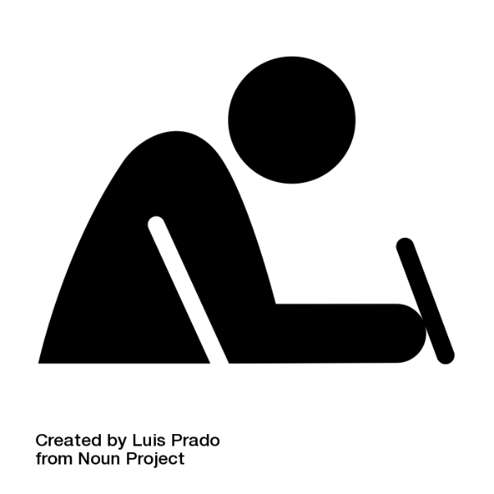
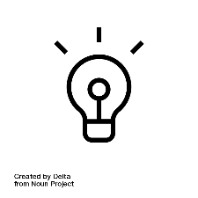
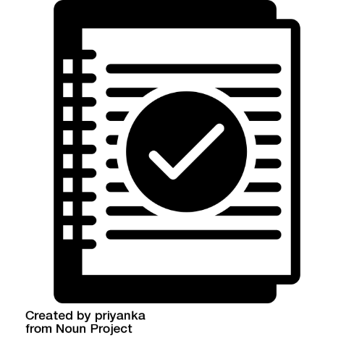

- Read the text or the learning materials that you want to summarize
- Then close your book and put away your learning materials. Write a summary from memory (recite): what do you still remember?
- Review your summary: did you note down everything important, was there something you missed? Check your learning materials and edit your summary until it’s complete. Was there something you did not understand? Check it!

With this method of summarizing, you combine summarizing with practicing retrieval. Furthermore, you will get a quick overview of topics that are easy for you to remember and understand and topics, that you need to work on more.

4. Summarizing using the Cornell method

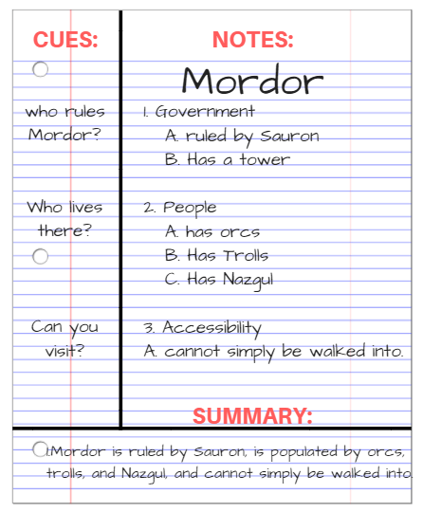
In summarization, students identify a text’s main points, excluding unimportant material. summarizing is a strategy to select the most important points and organize it. there are many different ways to summarize a text. for example, one can find the important sentences in the text to be read, and copy and paste them to another document. in this manner, summarization is barely different from highlighting and not effective for long-term learning. on the other hand, students can summarize by reading the text, thinking about it, attempting to understand it and then writing it down in their own words, as if they were explaining it to themselves. this technique is then more closely related to elaboration.

The Cornell-note taking technique is a useful technique as it supports active processing of the information after you have written your summary. Do not reread your summary, but test yourself with the questions you have written in the column (again, a combination with practice testing) and check your answers with your summary.

The exercise
Try to apply the Cornell method to an article that you have read before in the scheme below.
How to do it: start by writing the title of what you are summarizing at the top. Then you leave some space on one side of the page (left or right), and you use that space to write down keywords or test questions that pop up while summarizing. On the other (large) side of the line, you write your summary (the explanation of the keywords, the answers to your questions, possibly a visualization to help you understand). You could also take the learning goals from the pre-discussion as subheadings for your summary or write them on the side and try to answer them. If then later you want to test yourself, you can simply cover the summary part of the page and explain the keywords and answer the questions (try it!). An important advantage of this method is that you can immediately check whether you answered correctly.

Cues | Notes
- Write down questions or keywords, main ideas  - after you took notes / or during notetaking | - Write down main points and details from class/textbook/tutorial  - Write in your own words  - Make use of visualization
Summary | Write a short summary of what you’ve learned  - What did you learn today?  - Look back at your summary before the next class

You’re up!
Title (of the article):
Keywords/questions | Summary

Complement with keywords and/or questions to complete the Cornell scheme. In the scheme you have now made a summary on the right side, but the left column has been left blank. In that blank space, you can add those keywords and / or (short) questions. Thanks to this Cornell scheme you can easily test yourself: cover the right column; can you explain the keywords and answer the questions on the left side?
If you would like to continue using the Cornell method, please download the form from our website: www.studysmartpbl.com

5. ‘brain-dump’ or free recall

No time to make practice questions or just looking for an alternative? Then try a ‘brain-dump’:
Write down, draw, or simply tell a friend or yourself everything you still remember about a certain topic, learning goal, or chapter you have read. Make sure you also seek for feedback, did you miss something? Could you explain and retrieve everything correctly?

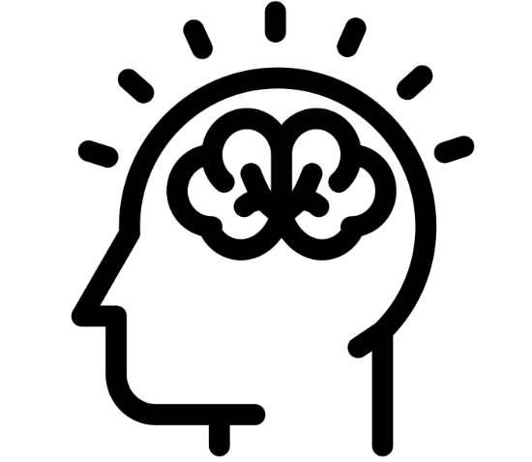

6. Mapping/Visualization
The strategy in short
Visualization in learning means expressing text or verbal information in pictures and graphs. By using both textual and visual information, this information will stick better in your memory. Why? We assume that we have to channels where new information gets into our memory: a visual channel and a textual channel. Combining those channels and integrating both, textual and visual information in our working memory creates stronger connections and makes it easier to connect to what we already know. It’s all about creating strong ‘mental models’, how information is stored in our memory. When you let text and images come together, two different ‘roads’ to the same information are created in memory. This means that you can also access this information more easily on a test: there are multiple ways to ‘cue’ that information. So it’s not about making a pictures and learning just that, but about learning both. This is also why you can work the other way as well: suppose a teacher used a picture in his / her lecture, then use that picture to see if you can explain the concept in words! You can also test yourself with a picture you have made or received from a teacher: can you explain the whole concept based on a picture?

How to do it:
- Get an overview of your learning material and wait a few minutes / hours
- Take an empty sheet of paper & start with the topic / learning goal in the middle. Note subthemes below or around
- Add examples, keywords or how things connect to each other
- Be active! Don’t look at your learning materials while mapping
- Check afterwards: do you have all important concepts? Are connections correct and clear?

Planning and time management

Use the Empty week scheme (on page 10) to complete:
- First, add all mandatory lessons, tutorials, exams you have to attend at the university (or online).
- Next, add all other regular activities, side jobs or social activities of that week.
- Next, plan necessary time to relax.
- As a last step, fill in your study time. When do they usually study and prepare for tutorials and exams? How much time is left?
- In the last part, also add some buffer study time, in case they did not finish their study tasks yet. This buffer time can become free time when the’ve finished their tasks.

Empty week scheme

Time | Monday | Tuesday | Wednesday | Thursday | Friday | Saturday | Sunday
8-9
9-10
10-11
11-12
12-13
13-14
14-15
15-16
16-17
17-18
18-19
19-20
20-21
21-22

Planned versus actual study

Time | Monday |  | Tuesday |  | Wednesday |  | Thursday |  | Friday |  | Saturday |  | Sunday
 | Plan | % | Plan | % | Plan | % | Plan | % | Plan | % | Plan | % | Plan | %
8-9
9-10
10-11
11-12
12-13
13-14
14-15
15-16
16-17
17-18
18-19
19-20
20-21
21-22

At the end of each day, estimate (in %) how much of what you planned to study you actually studied. This can help you to gain a more realistic view on your planning.

