WORKBOOK

Day 2: Practice

Practice: Effective learning strategies

Self-explanations

Asking questions before and while reading a text for the first time

We want to understand why things are the way they are. If we understand, we can remember it better. The materials are not only anchored more strongly in our memory, but also linked to our prior knowledge. That is why, while reading a text, you will start asking yourself questions while and after reading a text:
- Why? and How?
- Why is it needed to…? Why is this true? Why is this important to my field of study?
- How does this work…? How does it relate to what I already know?

Example
Paragraphs in the text | Questions you might ask
Why don’t students use more effective study techniques?  It seems they are not being taught the best strategies, perhaps because teachers themselves are not schooled in them.  A second problem may be that in the educational system, the emphasis is on teaching students critical-thinking skills and content. Less time is spent on teaching them how to learn.  The result can be that students who do well in their early years, when learning is closely supervised, may struggle once they are expected to regulate their own learning in high school or college. | Which strategies?  Why don’t students learn how to learn?  What is the result of this?
Some questions, such as the best age for students to start using a technique and how often they will need to be retrained or reminded, still require further research.  But even now teachers can incorporate the most successful approaches into lesson plans so that students could adopt them on their own.  For instance, when moving to a new section, a teacher can start by asking students to do a practice test that covers important ideas from the previous section and providing immediate feedback.  Students can interleave new problems with related ones from preceding units. Teachers can harness distributed practice by reintroducing major concepts during the course of several classes.  They can engage students in explanatory questioning by prompting them to consider how the information is new to them or why it might be true. | What could teachers do?  How can teachers support their students?  What does interleaving mean?
Adapted from: Dunlosky, J., Rawson, K. A., Marsh, E. J., Nathan, M. J., & Willingham, D. T. (2013). What works, what doesn’t. Scientific American Mind, 24(4), 46-53.
Now read your own text! Remember to ask yourself several questions throughout each paragraph. Stop and consciously go over what you’ve just read. In the beginning, it might be a challenge to come up with questions, but the more you do it, the easier it gets and the more questions pop into your head while reading!

Actively summarizing texts

The Read-recite-review method
Summarization can be a very effective as well as an extremely ineffective learning strategy. It is crucial that you are active while writing your summary, that means: write it in your own words (no copy-pasting from the textbook or lectures), think about examples or your own explanations, and include opportunities to test your knowledge in your summary. One way to do so, is the read-recite-review method:
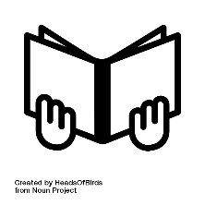
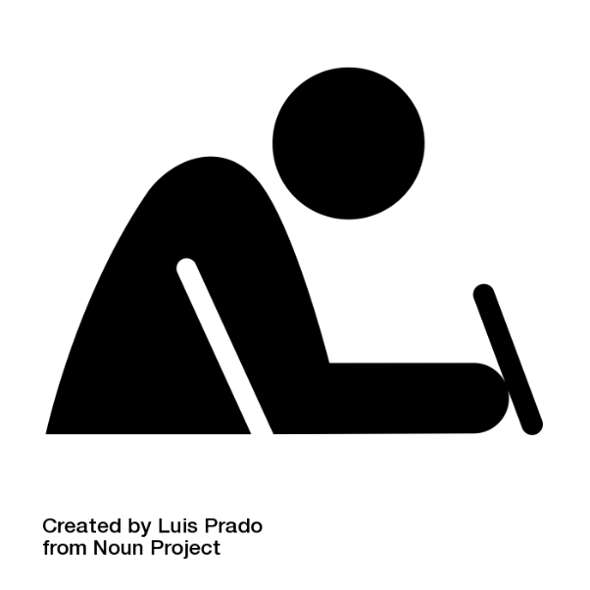
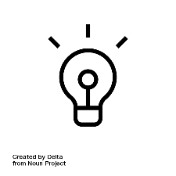
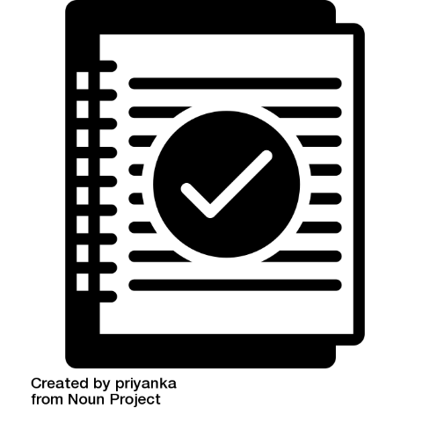

- Read the text or the learning materials that you want to summarize
- Then close your book and put away your learning materials. Write a summary from memory (recite): what do you still remember?
- Review your summary: did you note down everything important, was there something you missed? Check your learning materials and edit your summary until it’s complete. Was there something you did not understand? Check it!

With this method of summarizing, you combine summarizing with practicing retrieval. Furthermore, you will get a quick overview of topics that are easy for you to remember and understand and topics, that you need to work on more.

Summarizing using the Cornell method

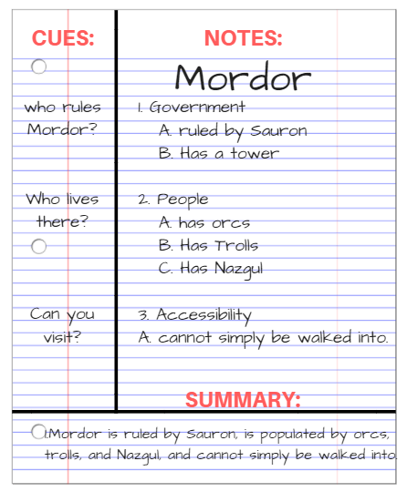
In summarization, students identify a text’s main points, excluding unimportant material. summarizing is a strategy to select the most important points and organize it. there are many different ways to summarize a text. for example, one can find the important sentences in the text to be read, and copy and paste them to another document. in this manner, summarization is barely different from highlighting and not effective for long-term learning. on the other hand, students can summarize by reading the text, thinking about it, attempting to understand it and then writing it down in their own words, as if they were explaining it to themselves. this technique is then more closely related to elaboration.

The Cornell-note taking technique is a useful technique as it supports active processing of the information after you have written your summary. Do not reread your summary, but test yourself with the questions you have written in the column (again, a combination with practice testing) and check your answers with your summary.

The exercise
Try to apply the Cornell method to an article that you have read before in the scheme below.
How to do it: start by writing the title of what you are summarizing at the top. Then you leave some space on one side of the page (left or right), and you use that space to write down keywords or test questions that pop up while summarizing. On the other (large) side of the line, you write your summary (the explanation of the keywords, the answers to your questions, possibly a visualization to help you understand). You could also take the learning goals from the pre-discussion as subheadings for your summary or write them on the side and try to answer them. If then later you want to test yourself, you can simply cover the summary part of the page and explain the keywords and answer the questions (try it!). An important advantage of this method is that you can immediately check whether you answered correctly.

Cues | Notes
- Write down questions or keywords, main ideas  - after you took notes / or during notetaking | - Write down main points and details from class/textbook/tutorial  - Write in your own words  - Make use of visualization
Summary | Write a short summary of what you’ve learned  - What did you learn today?  - Look back at your summary before the next class

You’re up!
Title (of the article):
Keywords/questions | Summary

Complement with keywords and/or questions to complete the Cornell scheme. In the scheme you have now made a summary on the right side, but the left column has been left blank. In that blank space, you can add those keywords and / or (short) questions. Thanks to this Cornell scheme you can easily test yourself: cover the right column; can you explain the keywords and answer the questions on the left side?
If you would like to continue using the Cornell method, please download the form from our website: www.studysmartpbl.com

Making a practice test

The essence of practice tests is: questioning yourself. This is a form of "retrieval practice": retrieving information from your memory. In this sense, it is actually a training of remembering. By answering practice questions, you are checking whether you can actively retrieve the studied materials from memory when asked. You hereby commit yourself to thinking more deeply. Possible ways of practicing retrieving information from your memory are:
- Complete practice tests (which you can write yourself, or get from teachers)
- Ask yourself questions about what you have studied, explain the answers to yourself and check whether the answers you gave yourself were indeed correct
- Someone else asks you a question and you explain the subject matter
- Create a practice test on flashcards about the text you need to learn (on paper or online: https://apps.ankiweb.net/ )
There is some overlap between the aforementioned strategies (self-explanations and summarizing using the Cornell method) and this method. This is because practicing answering questions can be easily integrated into other strategies to make them more effective (after all, you are more active with the material, and you practice retrieving the information).
By using the Cornell method to write your summaries, you are already writing practice test / flashcard questions, as it were: the keywords and questions in the margin or on one side of the card, the explanation or the answer next to it or on the other side. Furthermore, by using self-explanations while reading, you are already asking yourself practice questions about what you have read. It is also very useful to let others ask you questions, for example you can also create and exchange practice tests, so that you can practice more.
- Make a practice test using flashcards

For this exercise, you will practice making flashcards. You just can cut them out easily or write on the different sides, so we'll use a table for that. However, we can practice the way of asking!

Example

Front (question/keyword) | Back (answer/explanation)
What are effective learning strategies for long-term learning? | Make practice tests ("retrieval practice")  &  Distributed practice (returning to the topics you need to learn more often)
Which principles make learning strategies effective? | Active learning (actually actively working with the subject matter, for example asking questions about it) and immediate feedback (knowing whether you are doing well and why)
What are "desirable difficulties"? | Learning conditions that make initial learning more difficult but enhance long-term learning. This is the case in testing yourself (compared to rereading) or distributing study sessions over time (compared to crammed learning). Note: not everything that makes learning difficult (for example distractions) is desirable!

While you can make flashcards on paper, online flashcards are a very good and helpful alternative as you can keep an easy overview, observe your progress and the app help you with a smart algorithm to distribute your learning over time and to fight the forgetting curve.

Exercise Anki Flashcards:
We highly recommend the app Anki: https://apps.ankiweb.net/
In this exercise, download the app on your phone or your compute and familiarize yourself with the app. What are the options you can do? How can you use it? Take a first step to make your flashcards with Anki.
- Practice testing with ‘brain-dump’ or free recall

No time to make practice questions or just looking for an alternative? Then try a ‘brain-dump’: Write down, draw, or simply tell a friend or yourself everything you still remember about a certain topic, learning goal, or chapter you have read. Make sure you also seek for feedback, did you miss something? Could you explain and retrieve everything correctly?

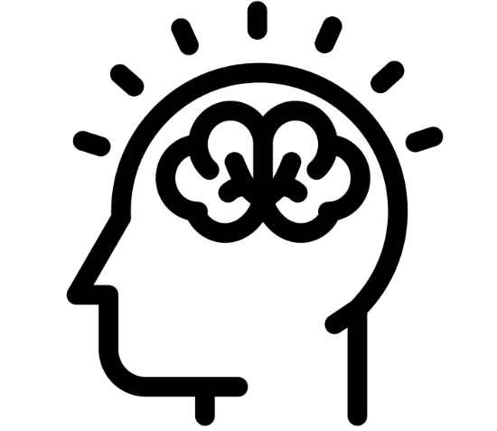

Visualization using the dual-coding method
The strategy in short
Visualization in learning means expressing text or verbal information in pictures and graphs. By using both textual and visual information, this information will stick better in your memory. Why? We assume that we have to channels where new information gets into our memory: a visual channel and a textual channel. Combining those channels and integrating both, textual and visual information in our working memory creates stronger connections and makes it easier to connect to what we already know. It’s all about creating strong ‘mental models’, how information is stored in our memory. When you let text and images come together, two different ‘roads’ to the same information are created in memory. This means that you can also access this information more easily on a test: there are multiple ways to ‘cue’ that information. So it’s not about making a pictures and learning just that, but about learning both. This is also why you can work the other way as well: suppose a teacher used a picture in his / her lecture, then use that picture to see if you can explain the concept in words! You can also test yourself with a picture you have made or received from a teacher: can you explain the whole concept based on a picture?

How to do it:
Structure your knowledge by drawing a process, combining or contrasting ideas in a mindmap, or creating graphs or diagrams. Try to come up with different ways to represent the information visually, for example an infographic, a timeline, a cartoon strip, or a diagram of parts that work together:
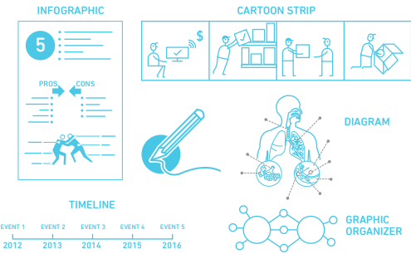
Furthermore, when reading a text, make a visual out of it (graph/diagram/mindmap), when studying a graph or visual, then explain it in your words: the dual-coding technique. Combine it with retrieval practice and try to write and draw from your memory. That way, you make visualization more effective.

It is important with this strategy to remember that not all material is suitable for expression in this way. Therefore, be critical of the articles / subject matter you brought along, whether this strategy is possible. If visualization is possible, focus on the important concepts in the text, the main message of the text, and think about a type of graphic that you can use (se picture above). Then start drawing it, and make sure that you can later explain what you have drawn.

Planning and time management

Use the Empty week scheme (on page 11) to complete:
- First, add all mandatory lessons, tutorials, exams you have to attend at the university (or online).
- Next, add all other regular activities, side jobs or social activities of that week.
- Next, plan necessary time to relax.
- As a last step, fill in your study time. When do they usually study and prepare for tutorials and exams? How much time is left?
- In the last part, also add some buffer study time, in case they did not finish their study tasks yet. This buffer time can become free time when the’ve finished their tasks.

Example:
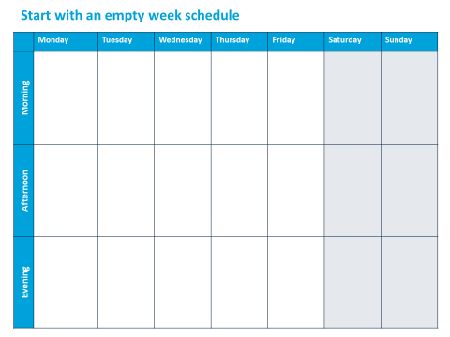
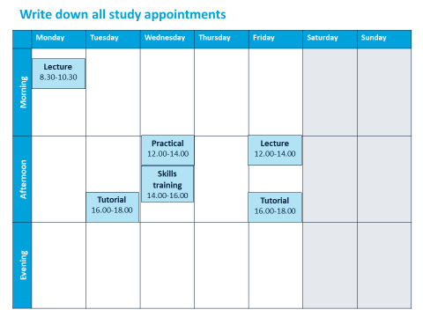
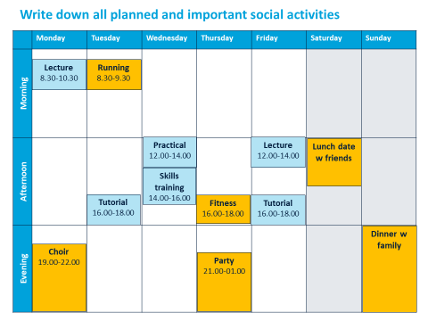
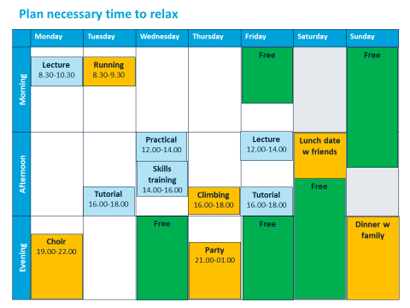
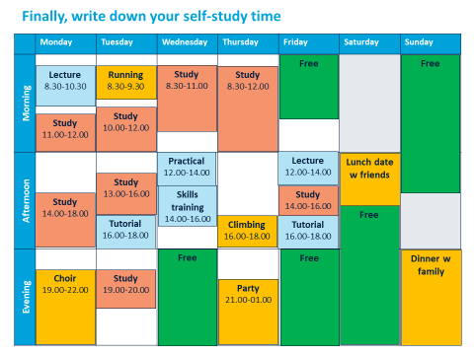
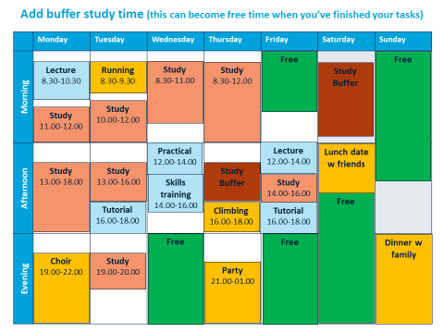

Empty week scheme

Time | Monday | Tuesday | Wednesday | Thursday | Friday | Saturday | Sunday
 | Plan | Plan | Plan | Plan | Plan | Plan | Plan
8-9
9-10
10-11
11-12
12-13
13-14
14-15
15-16
16-17
17-18
18-19
19-20
20-21
21-22

Planned versus actual study

Time | Monday |  | Tuesday |  | Wednesday |  | Thursday |  | Friday |  | Saturday |  | Sunday
 | Plan | % | Plan | % | Plan | % | Plan | % | Plan | % | Plan | % | Plan | %
8-9
9-10
10-11
11-12
12-13
13-14
14-15
15-16
16-17
17-18
18-19
19-20
20-21
21-22

At the end of each day, estimate (in %) how much of what you planned to study you actually studied. This can help you to gain a more realistic view on your planning.

Follow-up after practicing with the strategies

Think

How was it for you to practice these strategies? What obstacles do you think you might encounter?
Obstacles:

Pair
Discuss with your neighbor what you could learn from each other: how would the other deal with your obstacles?
Obstacle | Possible solutions

Share
Share your ideas (yours and your neighbor's), tips and tricks with the group. Pay close attention to what the other groups have discussed, and get new information for yourself from them! Fill them in in the schedule above.

Using effective learning strategies in your study sessions

Write out the goals you want to achieve for the next session! Use the schedule below. Be specific! Make sure that you can actually study based on what you fill out here. Also, make sure it's specific enough to assess next time how well you've adhered to these plans!
The strategy I will be using
How I will do this
With these materials

At these moment
The strategy I will be using
How I will do this
With these materials

At these moment
The strategy I will be using
How I will do this
With these materials

At these moment

Plan your next week - And plan when you plan the next week! Use the schedules on pages 11 & 12.

