WORKBOOK
Day 1: Awareness

Brainstorm: Often used learning strategies

Which learning strategies do you use?

Write down the strategies that you use while studying below. Think about what you do when you are reading something for the first time, but also how you repeat the materials, study them, and how you prepare for your exams.
Strategy:

Explanation:

Strategy:

Explanation:

Strategy:

Explanation:

Strategy:

Explanation:

Strategy:

Explanation:

Strategy:

Explanation:

Strategy:

Explanation:

Strategy:

Explanation:

Which of these strategies are your favorites? Give them a star rating.

Sorting cards: Learning strategies

Which strategies are effective for long-term learning?

Which strategies belong in which category? Place an ‘X’ where you think these strategies belong!
 | Very effective | Medium effective | Not effective
Summarizing
Self-explanations
Distributed practice
Rereading
Highlighting
Practice testing
Visualization
Interleaved practice

After you have filled this out entirely, your teacher will explain to you which of these strategies are effective, and why. Place another sign in the table (a # for example) where the scientific evidence would place these strategies. Which ones did you get wrong?
If you want to, you can use the table below to fill in why some strategies were (un)expectedly (in)effective:
Explanation
Summarizing
Self-explanations
Distributed practice
Rereading
Highlighting
Practice testing
Visualization
Interleaved practice

Brainstorm: Is your favorite learning strategy effective?

How could you make your strategies more effective?

On page 3 you’ve indicated your favorite strategies. Did these turn out to be effective, or not at all? In this assignment, we will attempt to make the strategies you are already using a little more effective. Think about how to make the strategy active, and to make sure you receive feedback about what you already know and what you do not yet know. Write down two ideas to make your strategies more effective:
My strategy
How effective is this strategy in itself?
How do I make the strategy more active?
How can I make sure to get feedback from the strategy?

My strategy
How effective is this strategy in itself?
How do I make the strategy more active?
How can I make sure to get feedback from the strategy?

Reflective writing: Putting in effort in other aspects of life
Reflecting on a different (not study-related) memory in which you have put in effort to learn something or change something
Think of a memory in which you learned something new by putting in a lot of practice (> 30 hours), something, which cost you a lot of effort (in sports, arts, music, computer etc.) OR Changed your behavior (for example: doing sports more often).
What have you learned?
How did you approach this?
How long did it take you to learn?
What did you do when it got tough?
Have you ever thought about quitting?
How did you convince yourself to pull through anyway?
What could someone have said to help you through this process?
What would you advise someone else who is going into the same learning process now?

Take a look at the intentions you wrote down to make your learning more active: how does your advice from the reflective writing exercise relate to the application of these new learning strategies? Think about the advice you gave yourself on the previous page. What would this mean for the application of the active strategies on page 5?
My intentions on page 5
My most prominent advice
How I will use this advice to make my strategies more active
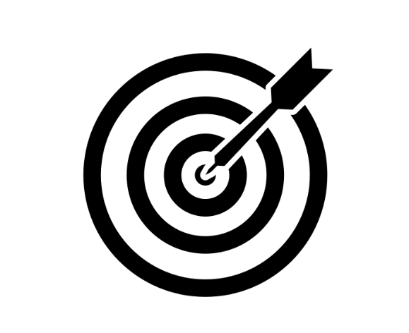
Listen to the advice your peers wrote down and discuss in the group. Use the space below to write down the useful advices they have given themselves or others:

How will you apply active learning in your studying? Set a goal for the upcoming period. Write down two specific ideas how you will make your strategies more effective.

